Winter Snow – Creative Ways to Teach STEAM
EECO Winter CONFERENCE January 31st and February 1st, 2020
The conferencewill be held at the fabulous Camp Nuhop, 1077 Hanover Twp. Rd. 2916, Perrysville, OH 44864.

Fees:
Full conference: (Friday-Saturday, 2 meals, snacks, and lodging) : Member $85 and Non-member $125
Saturday Only: (2 meals, snacks, no lodging): Member $45 and Non-member $85
Student: Full Conference: $50 ; Sat Only $30

Schedule and Session Descriptions

Friday- January 31, 2020
6:00 – 7:00pm Conference Registration and Room Check–in Location: Library
7:00 – 9:00pm Welcome/EECO Update and Roly Poly Races Location: Dinning Hall

EECO Update:
Current events and programs going on with EECO and partnering organizations.

Roly Poly Races:
Join Carrie Elvey from The Wilderness Center for a huge night full of tiny critters. Participants will enjoy an info session on the roly poly, and then pit their armored isopods against each other in a many legged race to glory! Carry will continue the fun on Saturday with a session on keeping roly pollies in the classroom.

Saturday – February 1, 2020
7:30 – 8:00am Morning Hike- Optional
8:00 – 9:00am Registration for Day Participants
8:00 – 8:45am Breakfast
9:00 – 10:00am Concurrent Sessions I
10:10 – 11:10am Concurrent Sessions II
11:30 – 1:00pm Lunch/Afternoon Optional Hike
1:15 – 2:15pm Keynote: Michelle Stitzlein
2:30 – 3:30pm Concurrent Sessions III
3:45 – 4:45pm Concurrent Session IV
5:00 pm Evaluations and Resource distribution

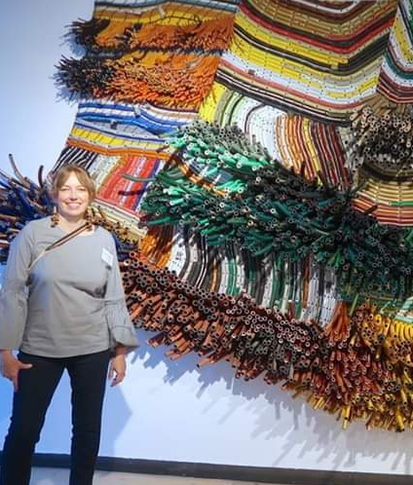
Saturday Keynote: Creative Reuse Inspired by Nature, Michelle Stitzlein
Michelle is an artist who has spent time all over the country creating pieces that are represented in museum and corporate collections such as libraries, science centers, and Art museums. During this presentation she will give a digital presentation about materials available in the waste stream, and how she has utilized them in her own artwork as well as collaborative projects within schools. She will also show images of art created with found and recycled materials by several inspiring artists viewed on her travels to India, South Africa, Namibia, Guatemala, Mexico, Colombia, and Peru.

Stitzlein was awarded two Individual Excellence Grants from the Ohio Arts Council in 2008 and 2017 and the Charley Harper Award from the Environmental Education Council of Ohio in 2019.

Session I Presentations:

Reading, Writing & Connecting with Nature: Terri Brest, The Wilderness Center
This session will examine multiple examples of science and nature themed children’s literature. We will look at ways to encourage children to make observations and discoveries, then tell, write or illustrate their own stories based on the original book as a model. Early Childhood- Library

An Outdoor Education Program for 5th Grader Kate Peresie, OCVN
In this session, participants will learn about a park district-sponsored nature journaling and field trip program for 5th graders that supports 5th grade science learning standards. We will do one or more of the lessons outdoors, weather permitting, so dress appropriately. Middle Grades- Library

Session II Presentations:

An authentic field science program for middle and high school students: Environmental Heroes, Advisor: Kathryn Kwiatkowski
Middle and high school students will share their research in an urban watershed, focused on the Doan Brook in University Circle, Cleveland, Ohio. Moving from a location in the Cleveland Metroparks, these students take on the challenges of collecting water quality data in local man-made ponds, Doan Brook, and Lake Erie. Attempts are made to collect data determining the abundance and distribution of fauna with a focus on amphibians and reptiles along the Doan Brook in and around University Circle. Their presentation will share their advocacy work that includes efforts to encourage the state legislature to develop and implement a statewide climate action plan and to save wetlands and forests. Middle School and High School- Dining Hall

Rolypoly-ology: Pillbugs in the classroom: Carrie Elvey, The Wilderness Center
Rolypoly, pill bug, potato bug, woodlouse – whatever you call these charismatic critters, they are the perfect classrooms animals. Learn to collect them, keep them alive (and contained) in the classroom, and use them as catalysts for investigations of all kinds. All Ages- Library

Session III Presentations:

Food Waste Warriors: Angela Rivera, Hamilton County Recycling and Solid Waste District
Lean to use the Be a Food Waste Warrior curriculum from World Wildlife Fund to help your students understand the impacts of wasting food and what they can do about it. This project-based learning curriculum allows students to conduct food waste audits in their school cafeteria, analyze data, and develop an action plan to address food waste in their school.Hamilton County Recycling and Solid Waste District conducted eighteen food waste audits in early 2019. We will present lessons learned and advice for implementing this program successfully in your school. Grades 5-12- Dining Hall

Microscopic Observation in the Dead of Winter: Amanda Kriner, Richland County Park District
Microscopes are an amazing tool for learning about the world for all ages. This session will provide lessons that allow for gathering of items outdoors to bring back into the classroom and observe using a digital microscope. We will discuss standard alignments for various grade levels, and using the microscope for ongoing indoor and outdoor inquiry throughout the year. All ages- Library

Session IV Presentations:

When in Rome, do as the Romans do! Incorporating Latin into your Classroom: Jason Larson, Richland County Park District
Kids are pressed throughout their academic careers to learn a foreign language like French or Spanish (that they hardly ever use), but for kids contemplating a career in science, Latin can be an incredible tool. It is the universal language for scientists around the globe. We'll gather some materials outside and then explore a variety of activities to enhance your curriculum for grades K-12, using this "very much alive" language. All Ages- Library

CSI: Critter Scene Investigation: Alli Shaw, Columbus and Franklin County Metroparks

There has been an incident at the park! Become a 5th grader and work on a research team. Using technology and process skills you will be observing evidence, gathering data, problem solving, and drawing conclusions. This is an indoor activity and mentally, rather than physically, challenging. All Ages– Dining Hall

