Teachers, are you looking for college credit for your certification?
Consider Exploring Project WILD and Growing Up WILD in the Winter Snow!

Winter Snow – Creative Ways to
Teach STEM
EECO Winter CONFERENCE
January 29th and 30th, 2021
Presentation topics include: Snow Flow, Human Ecology, Mammal Tracks, Environmental Heroes, Science of Fat and Woody Plants
Registration: $10 for EECO Members and $35 for Non-members
For more information and to register:
Register online and view Conference agenda at
EECO Winter Conference: Winter Snow - Creative Ways to Teach STEAM

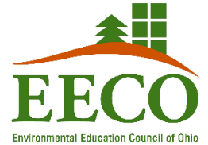

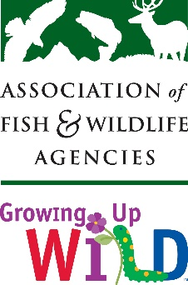
Growing Up WILD
February 12-19, 2021
Growing Up WILD: Exploring Nature with Young Children is Project WILD's early childhood education activity guide. It is written for preK -2nd grade and contains 27 hands-on, field tested activities that focus on wildlife and nature. Guide and activity kit will be received upon completion.
Course is self-paced and takes 3-6 hours to complete.
Workshop is held using the Microsoft Teams platform.
Sponsored by the Ohio Division of Wildlife.

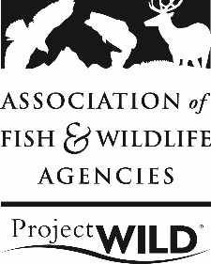
Project WILD and Aquatic WILD
February 19-26, 2021
Participants will learn how to incorporate fish and wildlife-based activities into their everyday curriculum to help students understand conservation and experience the outdoors in a sustainable way. Both guides and activity kit will be received upon completion.
Course is self-paced and takes 3-6 hours to complete.
Workshop is held using the Microsoft Teams platform.
Sponsored by the Ohio Division of Wildlife.

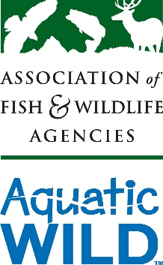

By completing all three workshops you will:
- Gain resources to enhance STEM lessons
- Obtain Growing Up WILD guide and activity kit
- Receive both the K-12 Terrestrial and Aquatic WILD guides
- Meet environmental educators and resource personnel from across the state
- Earn 1 semester hour of graduate credit through Ashland University (with course completion and an additional fee of $195 payable to Ashland University)
- Questions? Contact Linda Pettit at lpettit@franklinswcd.org

