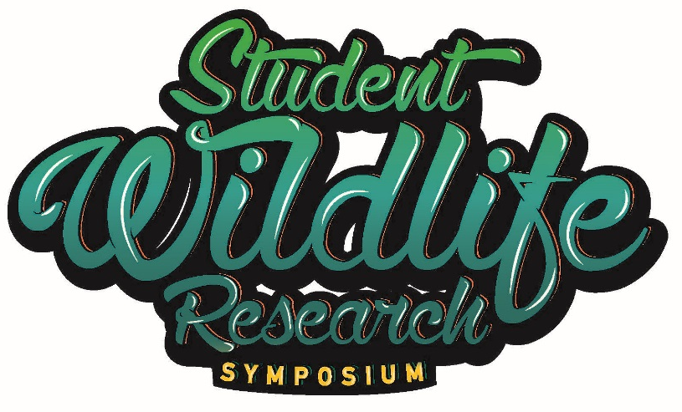

Fifth Annual Student Wildlife Research Symposium
Annual EECO Conference
April 13, 2023

9:00-9:45am Registration and Poster Set-up

10:00am Opening Remarks- ODNR-Division of Wildlife

10:15am Keynote- How to Increase Student Interest by Offering Lessons Involving Real Science by Jeff Baker-ALPHA Program- -Jeff teaches students who come through the court system. Therefore, all of them are at-risk and credit deficient. After studying more about scientific inquiry during his MAT in biology studies at Miami University of Ohio, he began to change the way he taught science from giving information to asking questions. He now has two published papers in the American Biology Teacher based entirely on student-driven studies using real scientific investigation. He has found the key to student interest is allowing them the freedom to have input into the lesson design.

11:00am A Bird’s Eye View by Clay Buescher, Connor Piero, Teddy Welsh, Brandon Parks, Sammy Weidenthal, University School—In fall of 2022, a survey was conducted to document bird-window collisions on campus during fall migration. The goal was to document the problem, propose the solution, and develop a long-term study for future students to continue in the spring.

11:30am An Investigation of Propagation Methods for Reintroduction of Eradicated Eelgrass by Emma Reding and Claire Mialky, Granville High School This presentation will outline the various experimental models and best practices we incorporated to propagate eelgrass in controlled environments, concluding with the re-introduction of eelgrass into a restored wetland (GEVSD Land Lab). We tested the input of current, various growth mediums, and the effects of other animals (fish) on growth.

11:55am Introduce Poster Presenters

12:00pm Lunch-- Meet a Biologist! Meet and greet with ODNR and other resource agency staff. Meet Wildlife Officers, Wildlife Area Managers, and Fish Management staff and see their equipment too. This is an opportunity to interact with professionals in the field of environmental science.

1:15pm Poster Session-Review Posters and discussions with students—Please see Poster Session abstract for descriptions.

2:00pm Distribution of Blacklegged Ticks and Borrelia burgdorferi prevalence in Tuscarawas County, Ohio by Addy Kendle, Elizabeth Dorsey, Amber Albritton, Jordynne Weese-New Philadelphia High School—This study examined the distribution of Blacklegged Ticks and the prevalence of the pathogen that cause Lyme Disease across Tuscarawas County, OH

2:30pm What are the Social Interactions Between Three Red Harvester Ant Colonies? by Brady Tindall, Delaware Area Career Center-This study documented ant behaviors during foraging and pollination among three different ant colonies that were combined together.

3:00 pm A Study of Chloride Retention Levels From Excess Use of Road Salt in Wolf Run Tributary in Comparison to Kokosing River Levels by Juliella Hankinson—--Excess road salt is washed off roads into soil and nearby waterways creating elevated chloride levels in fresh water. This study tested chloride levels, temperature, and tributary water level in Wolf Run tributary and the Kokosing River to determine chloride levels and compare results to one another and previous measurements.

3:20 pm Closing Remarks-Jen Dennison, Wildlife Education Coordinator, ODNR-Division of Wildlife

3:30 pm Safe Travels! See you next year at Salt Fork State Park Lodge April 11-14, 2024!

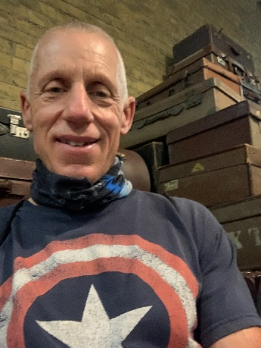
Jeff Baker has a BA in Biology from Denison University and a MAT in Biology from Miami University of Ohio. He has 15 years in teaching biology combined with over 20 years in pharmaceutical sales, giving him a unique perspective on various aspects of biology, especially involving the cell and genetics, and am recognized by the Ohio Department of Education as an Accomplished teacher, Currently, he has two published papers in The American Biology Teacher-both based on science done by students outside the regular classroom. In addition, he is certified by the Environmental Education Council of Ohio to teach environmental science, he is also certified to teach Project WILD, Project WET, and PLT. He is also recognized as a Phenology Leader and is on the board of the Licking County Soil and Water Conservation District.

