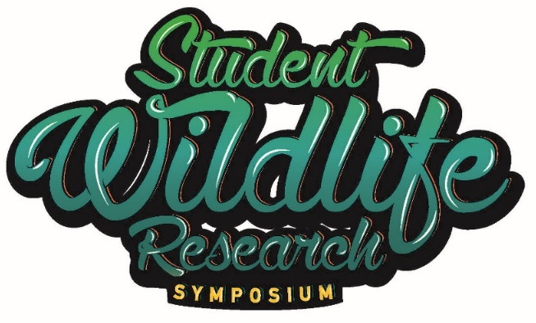

Sixth Annual Student Wildlife Research Symposium
Annual EECO Conference
April 11, 2024

9:00-9:45am Registration and Poster Set-up

10:00am Opening Remarks- ODNR-Division of Wildlife
Jen Dennison-Welcome
Scott Butterworth-150th Anniversary video

10:15am Keynote- Not Everything That Counts Can Be Counted: Lessons Learned in the Recovery of the Lake Erie Watersnake, Kristin Stanford, Ohio Division of Wildlife- -Kristin will showcase her research and recovery plan for Ohio’s population of the now delisted Lake Erie watersnake, a subspecies endemic to Ohio’s Lake Erie Islands, as well as the impact that her outreach program, www.respectthesnake.com had on the recovery of this once endangered species.

11:00am Student Presenter-TBD

11:30am Student Presenter-TBD

11:55am Introduce Poster Presenters
Brenda-Career Introduction

12:00pm Lunch-- Meet a Biologist! Meet and greet with ODNR and other resource agency staff. Meet Wildlife Officers, Wildlife Area Managers, and Fish Management staff and see their equipment too. This is an opportunity to interact with professionals in the field of environmental science.

1:15pm Poster Session-Review Posters and discussions with students—Please see Poster Session abstract for descriptions.
Kendra and/or the Director-a few words

2:00pm Student Presenter-TBD

2:30pm Student Presenter-TBD

3:00 pm Student Presenter-TBD

3:20 pm Closing Remarks-Jen Dennison, Wildlife Education Coordinator, ODNR-Division of Wildlife
Brenda-details for next year?

3:30 pm Safe Travels! See you next year April 3-6, 2025!

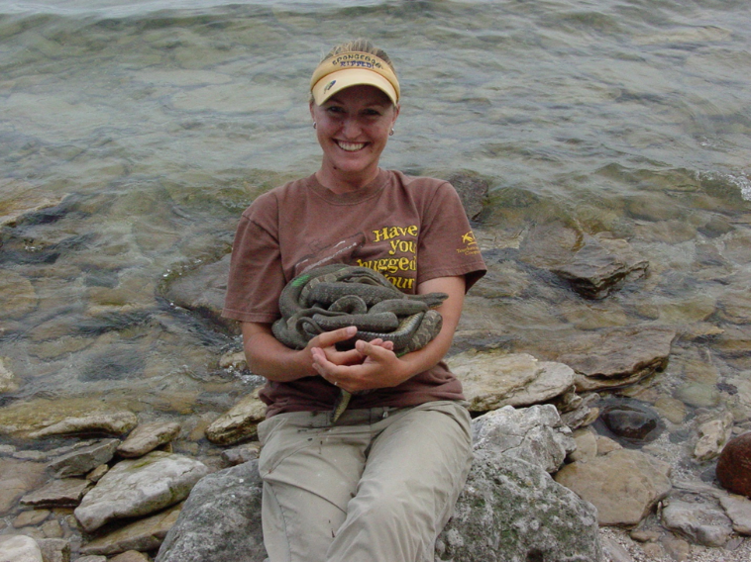
Dr. Kristin Stanford received her B.S., M.S. and Ph.D. from Northern Illinois University. She has been coordinating Lake Erie watersnake (LEWS) conservation for more than 20 years and served as the Recovery Coordinator from 2003-2011 until the subspecies was successfully delisted. She founded the Respect the Snake initiative (www.respectthesnake.com) which continues to facilitate the research, management and outreach needed to conserve the LEWS and other native snake species. She served as the Education and Outreach Coordinator for the Ohio State University’s biological field station, Stone Laboratory from 2012-2022 and was responsible for overseeing logistics for this nationally recognized education and outreach program before recently accepting the role of Wildlife Diversity Coordinator for the Ohio Division of Wildlife. Kristin and her husband Jon live on South Bass Island with their 5 children, Richard (17), Juliana (15), Katie (13), Vincent (9) and Vivian (8).

Abstract: Not everything that counts can be counted: Lessons learned in the recovery of the Lake Erie watersnake
Although qualitative goals can present challenges when measuring success, they are often just as important as quantitative goals when it comes to ensuring the long term conservation of species. Listed as threatened in 1999 and recovered in 2011, the Lake Erie watersnake (Nerodia sipedon insularum) represents one of the most rapid species recovery stories of the Endangered Species Act. But what can the recovery of a small population of endemic watersnakes teach us about conservation on a larger scale? The federal recovery plan, implemented in 2003, had three largely quantitative recovery criterion including assessing and securing overall and island specific population sizes and habitats as well as reducing intentional human persecution. However, several qualitative strategies were utilized to achieve these quantitative goals. Here we present these strategies from the success story of the LEWS that can be applied in other conservation programs. These include: (1) being proactive in initial recovery efforts; (2) utilizing pre-established partnerships to tackle multiple recovery tasks; (3) staying positive, but prudent in the face of tackling ophiophobia; (4) being persistent with the conservation message; (5) having patience with the overall process; and (6) bringing passion whenever possible. The continued partnering of both quantitative and qualitative conservation efforts is vitally important for ensuring the long term recovery success for this species.

